Session-8

1).Write a PL/SQL block that declares two variables: one for a user's name (VARCHAR2) and one for their age (NUMBER). Assign values and print both using DBMS_OUTPUT.PUT_LINE.

Ans DELIMITER $$

CREATE PROCEDURE user_details()
BEGIN
DECLARE v_name VARCHAR(50);
DECLARE v_age INT;

SET v_name = 'Om Vankar';
SET v_age = 21;

SELECT v_name AS Name, v_age AS Age;
END $$

DELIMITER ;

CALL user_details();
Output:- 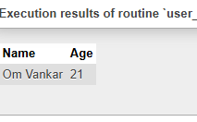

2).Create a PL/SQL block that uses an IF statement to check if a given order amount is above 500. If yes, print 'Eligible for free delivery', else print 'Delivery charges apply'.

Ans) DELIMITER $$

CREATE PROCEDURE free_delivery()
BEGIN
DECLARE order_amount INT;

SET order_amount = 650;

IF order_amount > 500 THEN
SELECT 'Eligible for free delivery' AS Message;
ELSE
SELECT 'Delivery charges apply' AS Message;
END IF;
END $$

DELIMITER ;

CALL free_delivery();

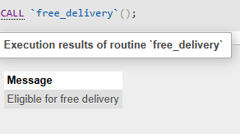
3).Write a PL/SQL block that uses a simple LOOP to print the numbers 1 to 5 using DBMS_OUTPUT.PUT_LINE.<br><br><em><strong>Hint:</strong> Use a counter variable and EXIT WHEN condition inside the loop.</em>

AnsDELIMITER $$

CREATE PROCEDURE print_numbers()
BEGIN
DECLARE counter INT DEFAULT 1;

simple_loop: LOOP
SELECT counter AS Number;
SET counter = counter + 1;

IF counter > 5 THEN
LEAVE simple_loop;
END IF;
END LOOP;
END $$

DELIMITER ;

CALL print_numbers();
Output:-
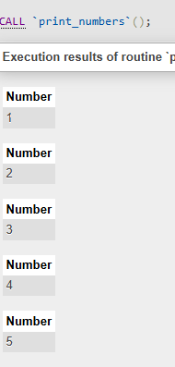

4)Declare a cursor in PL/SQL to select all product names from a table called PRODUCTS. Fetch each product name and print it using DBMS_OUTPUT.PUT_LINE.<br><br><em><strong>Hint:</strong> Assume the PRODUCTS table has a column PRODUCT_NAME.</em>

Ans) DELIMITER $$

CREATE PROCEDURE show_products()
BEGIN
DECLARE done INT DEFAULT FALSE;
DECLARE p_name VARCHAR(100);

DECLARE cur CURSOR FOR
SELECT product_name FROM products;

DECLARE CONTINUE HANDLER FOR NOT FOUND
SET done = TRUE;

OPEN cur;

read_loop: LOOP
FETCH cur INTO p_name;

IF done THEN
LEAVE read_loop;
END IF;

SELECT p_name AS Product_Name;
END LOOP;

CLOSE cur;
END $$

DELIMITER ;

CALL show_products();

Output:-
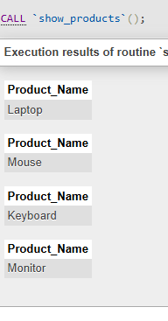

5)Write a PL/SQL block that tries to divide two numbers entered as variables. If a division by zero occurs, catch the exception and print 'Cannot divide by zero'. Otherwise, print the result.

AnsDELIMITER $$

CREATE PROCEDURE divide_numbers()
BEGIN
DECLARE num1 DOUBLE DEFAULT 100;
DECLARE num2 DOUBLE DEFAULT 0;

IF num2 = 0 THEN
SELECT 'Cannot divide by zero' AS Message;
ELSE
SELECT num1 / num2 AS Result;
END IF;
END $$

DELIMITER ;

CALL divide_numbers();Output:-
